**Assignment#9**

**Saikiran Reddy Gokula**

Launched GUI Application For Exercise Tracking

All Fields are Disabled Until Log In To The Application

File Menu Contains Login,Logout,Save &Exit Options

Log In Dialog

Validation For UserName & Password

Logged In With Valid Details

Clicked On Add Exercises Button Without Filling The Details

Filled Details & Selected Run/Walk Exercise Type

Filled Details Displayed Under The Exercise Summary With Total Calories Burned Value

Selected Rock Climbing Exercise Type & Entered Wall Height and Repetitions

Selected Weight Lifting Exercise Type & Entered Total Weight Lifted

Listed All The Details Under The Exercise Summary Panel

Sorted The Details By Date

Entered One More Exercise

Sorted The Details By Calories

Help Menu & About Option

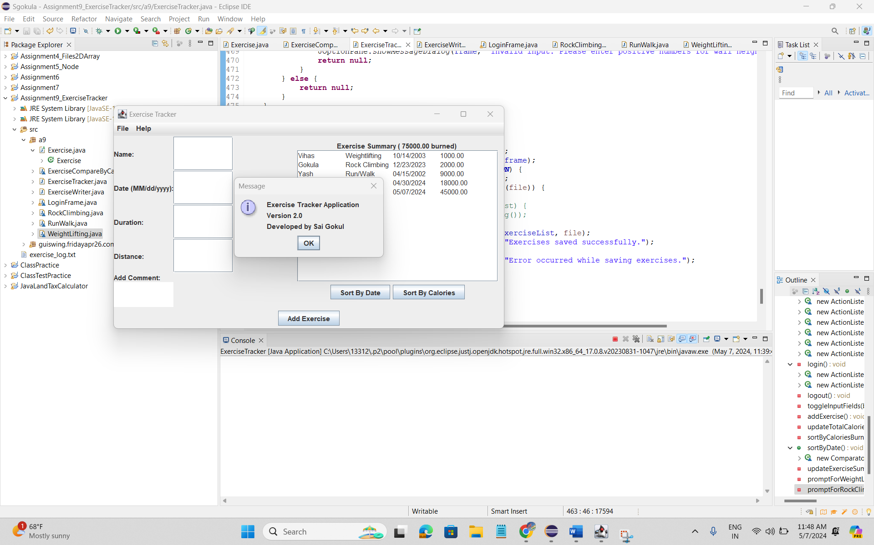

Save Option From The File Menu

Saved File Data & Displayed With Exercise Details

Logged Out From The Application

All The Fields Are Disabled & Sort By Date , Calories Buttons Are Not Visible

Exited From The Application By Using EXIT Option From File Menu.

Note: Source Code Pushed To The GIT Repository